Chelford Neighbourhood Plan Page 1

Help Shape the Future of Our Community

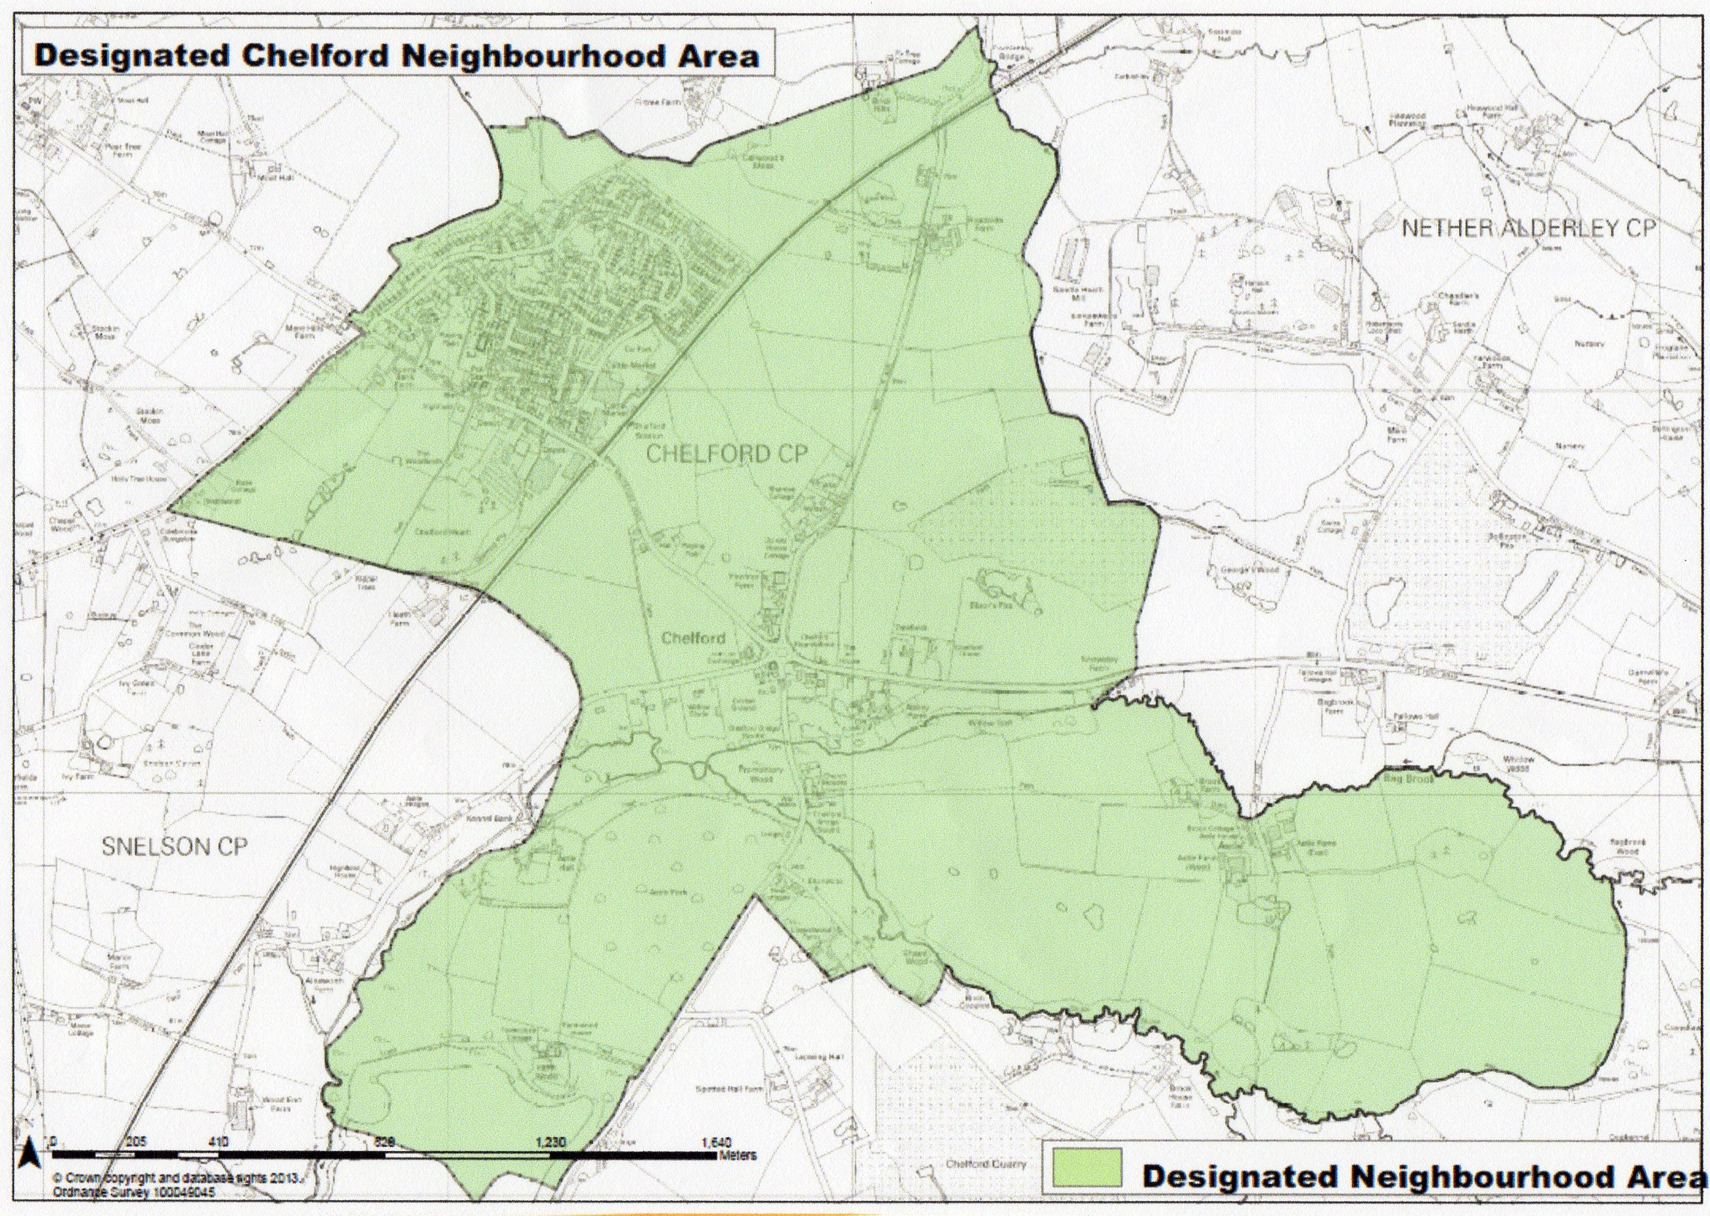

What is a Neighbourhood Plan?

- A Neighbourhood Plan is an opportunity for every resident in Chelford to have a say in how Chelford Parish should develop up to 2030 to meet local needs.

- Neighbourhood Plans are important planning documents. When completed and accepted, the plan will have legal status for planning purposes. Cheshire East planners must use the plan, alongside their local plan, to determine planning decisions of future development in the parish.

- The Neighbourhood Plan must conform to the principles and strategies of the Cheshire East Local Plan and although our plan cannot stop future development, it will give us a major say in influencing and shaping that development.

- There are approximately 50 Neighbourhood Plans in Cheshire East underway or completed. They are being used successfully to help decide planning applications and have been used to fight appeals.

- A Neighbourhood Plan can allocate sites for development and can have a number of policies covering planning issues such as housing, local character and design, the natural environment, community facilities and more.

Why Have We Decided to Produce a Neighbourhood Plan?

- Our parish is about to undergo significant change with two new housing developments, which could increase the population by almost 500 people (+40%) and the housing stock by about 180 dwellings (+36%)

- Chelford is experiencing pressure from landowners and developers to take land out of the green belt and build even more homes.

- A Neighbourhood Plan will allow us to state where and how we want future development to occur--housing, businesses, services, infrastructure

page 2

- A Neighbourhood Plan will offer us a measure of control and influence to ensure that the parish grows and develops in an appropriate and acceptable way.

What Do We Have To Do?

- The plan is a community plan not a Parish Council Plan, although the Parish Council has overall responsibility for the process

- We have to consult with all interests in the parish including residents of all ages, businesses and other organisations and any other interested parties, so that we can gain information on their future needs and issues.

- We will hold public events and consultations at different stages of the Neighbourhood Plan process to ensure that everyone is well informed and has the opportunity to make their views known

- We will keep you informed regularly and all relevant documents, information and updates can be found on the Village Website via the Neighbourhood Planning Portal on the Home Page.

- We must gather a wide variety of information and evidence; analyse it in detail and then use it in order to write the plan

- We have to prepare a draft document which is then subject to public consultation, before being formally submitted to Cheshire East for further consultation, prior to independent examination

- Cheshire East will then organise a referendum of Chelford residents on the electoral roll, at which 50% of votes cast must be in favour of the Plan before it can be formally adopted.

What Have We Done So Far?

- We have gone through the required consultation process with Cheshire East to have our Neighbourhood Area designated (see map on page 1)

- We have formed a Steering Group which has drawn up a project plan; has successfully bid for central government funding; has gained consultancy support; has begun the consultation process

How Long Will It Take?

- It is a major project, which will require considerable work. It will require the help of a number of volunteers to work on specific aspects of the plan.

- We are aiming to complete the process by the end of 2018 but this will require your help by completing questionnaires thoroughly and returning them promptly; getting involved in consultations; and where possible by volunteering to help the planning team.

NOW GO TO PAGES 3 and 4.

PLEASE ANSWER ALL THE QUESTIONS

All responses will remain anonymous and will be treated as confidential

RESIDENTS’ SURVEY Page 3

We want to know your views on Chelford Parish and what are the main planning issues over the next 13 years that we should consider in the Neighbourhood Plan?

This information will help us draw up a vision and objectives for Chelford and help us to design a more detailed questionnaire, which we will then ask you to complete in due course. This will help us draft planning policies.

Please complete all aspects of the questionnaire. If you prefer it can be completed online using the Neighbourhood Plan link on the Village website home page. Additional copies can be obtained from local shops.

- What do you like about living in Chelford Parish?

a)

b)

c)

2. What do you dislike about living in Chelford Parish?

a)

b)

c)

3. What do you see as the main threats for the future of Chelford Parish?

a)

b)

c)

4. By 2030, please describe what type of place you would like Chelford to be?

PTO
Page 4
5. Do you agree that the main planning issues below, should be considered by the Planning Group
when developing a Neighbourhood Plan up to 2030? Please indicate with a tick by Yes or
No and also rank them in order of importance to you e.g. 1 being the most important.
(Please note that issues relate to land use planning)
RANK

a) Housing Mix/Tenure YES NO

b) Location of Any New Developments YES NO

c) Design of Any New Developments YES NO

d) Employment and the Local Economy YES NO

e) Infrastructure (e.g. parking, broadband ) YES NO

f) Community Facilities (e.g. leisure/recreation) YES NO

g) The Natural Environment YES NO

h) Historic Buildings YES NO

6. Please state any other issues that you think we should consider when developing the
Plan ( Please note that issues must relate to land use planning and should not include
things as road maintenance, litter, speeding, bus services, etc).

i)______________________________________________________________________

_______________________________________________________________________

ii)______________________________________________________________________

_______________________________________________________________________

iii)_____________________________________________________________________

_______________________________________________________________________

Thank you for completing this first questionnaire. One of our representatives will call and collect your responses

Responses may also be left in the following local shops in the appropriate box:
AJ Boons Butchers, Chelford Newsagents. Chelford Surgery

If you would like to be involved in anyway with developing the Neighbourhood Plan, please contact the Clerk to Chelford Parish Council at:

clerk.chelfordpc@gmail.com Tel: 01477 571 444

