Chelford Neighbourhood Plan

Help Shape the Future of Our Community

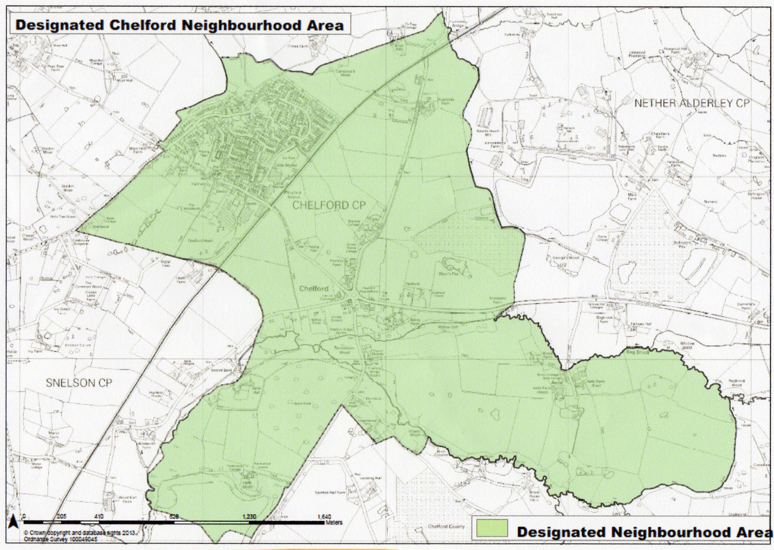

What is a Neighbourhood Plan?

- A Neighbourhood Plan is an opportunity for every resident in Chelford to have a say in how Chelford Parish should develop up to 2030 to meet local needs. Every resident means just that. It is important that younger residents have an input into the Neighbourhood Plan as well as their parents

- These Plans are important documents. They help to ensure that the area you live in reflects your needs as well as others. Once the Plan is agreed it will give the residents of Chelford an opportunity to influence and shape any future developments up to 2030.

- A Neighbourhood Plan can allocate sites for development and can have a number of policies covering planning issues such as housing, local character and design, the natural environment, community facilities and more.

Why Have We Decided to Produce a Neighbourhood Plan?

- Chelford is about to undergo significant change with two new housing developments, which could increase the population by almost 500 people (+40%) and the housing stock by about 180 dwellings (+36%)

- By completing this simple questionnaire you will enable the Parish Council to influence future developments for the area thanks to the views you have shared with us.

- All responses will remain anonymous and will be treated as confidential

YOUNG PERSON QUESTIONNAIRE

We want to know your views on Chelford now and what we should plan for in the future to make Chelford a good place to live and work. Please complete all aspects of the questionnaire.

- What three things do like about living in Chelford?

i)________________________________________________________________________________

_________________________________________________________________________________

ii)_______________________________________________________________________________

________________________________________________________________________________

iii)_______________________________________________________________________________

________________________________________________________________________________

- What three things do you think might make Chelford a better place to live in?

i)________________________________________________________________________________

_________________________________________________________________________________

ii)_______________________________________________________________________________

_________________________________________________________________________________

iii)_______________________________________________________________________________

________________________________________________________________________________

3. By 2030 please describe what type of place you would like Chelford to be.

Thank you for completing this questionnaire. One of our representatives will call and collect your responses. If you would like to be involved in anyway with developing the Neighbourhood Plan, please contact the Clerk to Chelford Parish Council at:

clerk.chelfordpc@gmail.com Tel: 01477 571 444

